Daviess County Library
Photography Contest Rules - Summer 2024
“The doors of Daviess COUNTY”

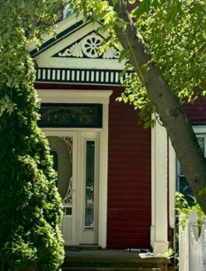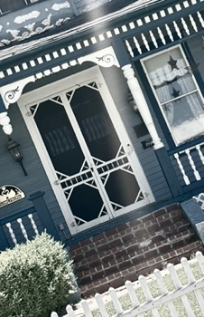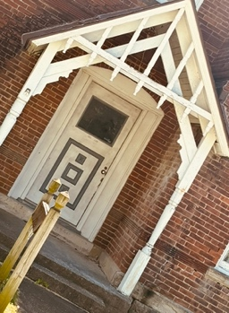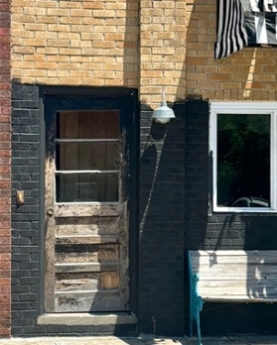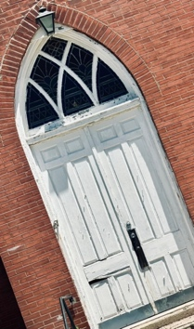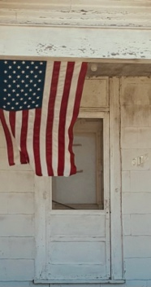

AGE CATEGORIES 12-17
ADULT 18+
Doors must be taken in Daviess County, Missouri between June 13th and June 29th.

You may submit multiple photos.

All entries due by midnight on June 29th, 2024. No late entries accepted.

Include camera information and general location for each entry.

Photos must be Original Work, taken by entrant. The photo must not infringe upon the trademark, copyright, moral rights, intellectual rights, or rights of privacy of any entity or person.

Entries will be judged by the Daviess County Library. All decisions are final. The Library reserves the right to disqualify any entry that is deemed inappropriate or does not conform to contest rules.


306 W. Grand
Gallatin, MO. 64640
daviesscountylibrary.org
660-663-3222

Submit entries to daviesscirculationassistant@gmail.com before midnight on June 29th.
A photo from each category will be chosen and rendered on canvas to be displayed in the library. An honorable mention photo may also be chosen from each group.

